Java: Platform independent

Source code -> .java -> compile (javac) -> .class file (bytecode: jvm ): platform independent

Machine language: hardware: registers, 16, 32 bit,

ADD 5, R0

Binary 0,1

Windows 32 bits: jvm for my machine (bytecode)->{JVM }(JIT compiler, interpreter) machine language-> executed

Pointers:

Automatic garbage collection: daemon thread sweeping away (deconstructors)

Exception handling: 5/0: checked | unchecked

Multithreading| Multiprocessing

Networking: classes :

Java 11:

Java 8 rt.jar: java.io (100mbs)

Java.lang

Java.util

Classloaders executing my app -> load my rt.jar into the memory

Source code -> class file -> class loader subsystem {bootstrap, extension, application/system}

: Java 9( Module system)(10mb)

C : source code -> compile -> machine language (hardware independent)

Bytecode:

Jdk: Java development kit: tools necessary for developers (libraries), compiler, debugger, Javadoc+ jre

jre (Java runtime environment: run java based app: class file: java , libraries + JVM)

JVM: java virtual machine (OS) : hard disk : jvm executed

Memory space: ram (heap, stack, method area/ perm gen space)

Heap: objects

Stack: local variables | thread | method

Method area: loaded + class objects| static variables

Data Types in java

1. Primitive: Non-numeric: char(2 bytes), boolean ; Numeric: int(4), float(4), double(8), long(8), byte(1), short(2)
2. Objects: Interfaces, Class references, arrays

Byte: -128 -> +127

Short: -32768 -> 32767

Int: -2147483648 -> +2147483647

Pass by value?

Pass by reference?

Operators:

Arithmetic: -, +, * ,/ , %, +=, *=, /=, ++

Int a=2;

Int b=a++;//post increment

Sysout(b);//2

Sysout(a) ; //3

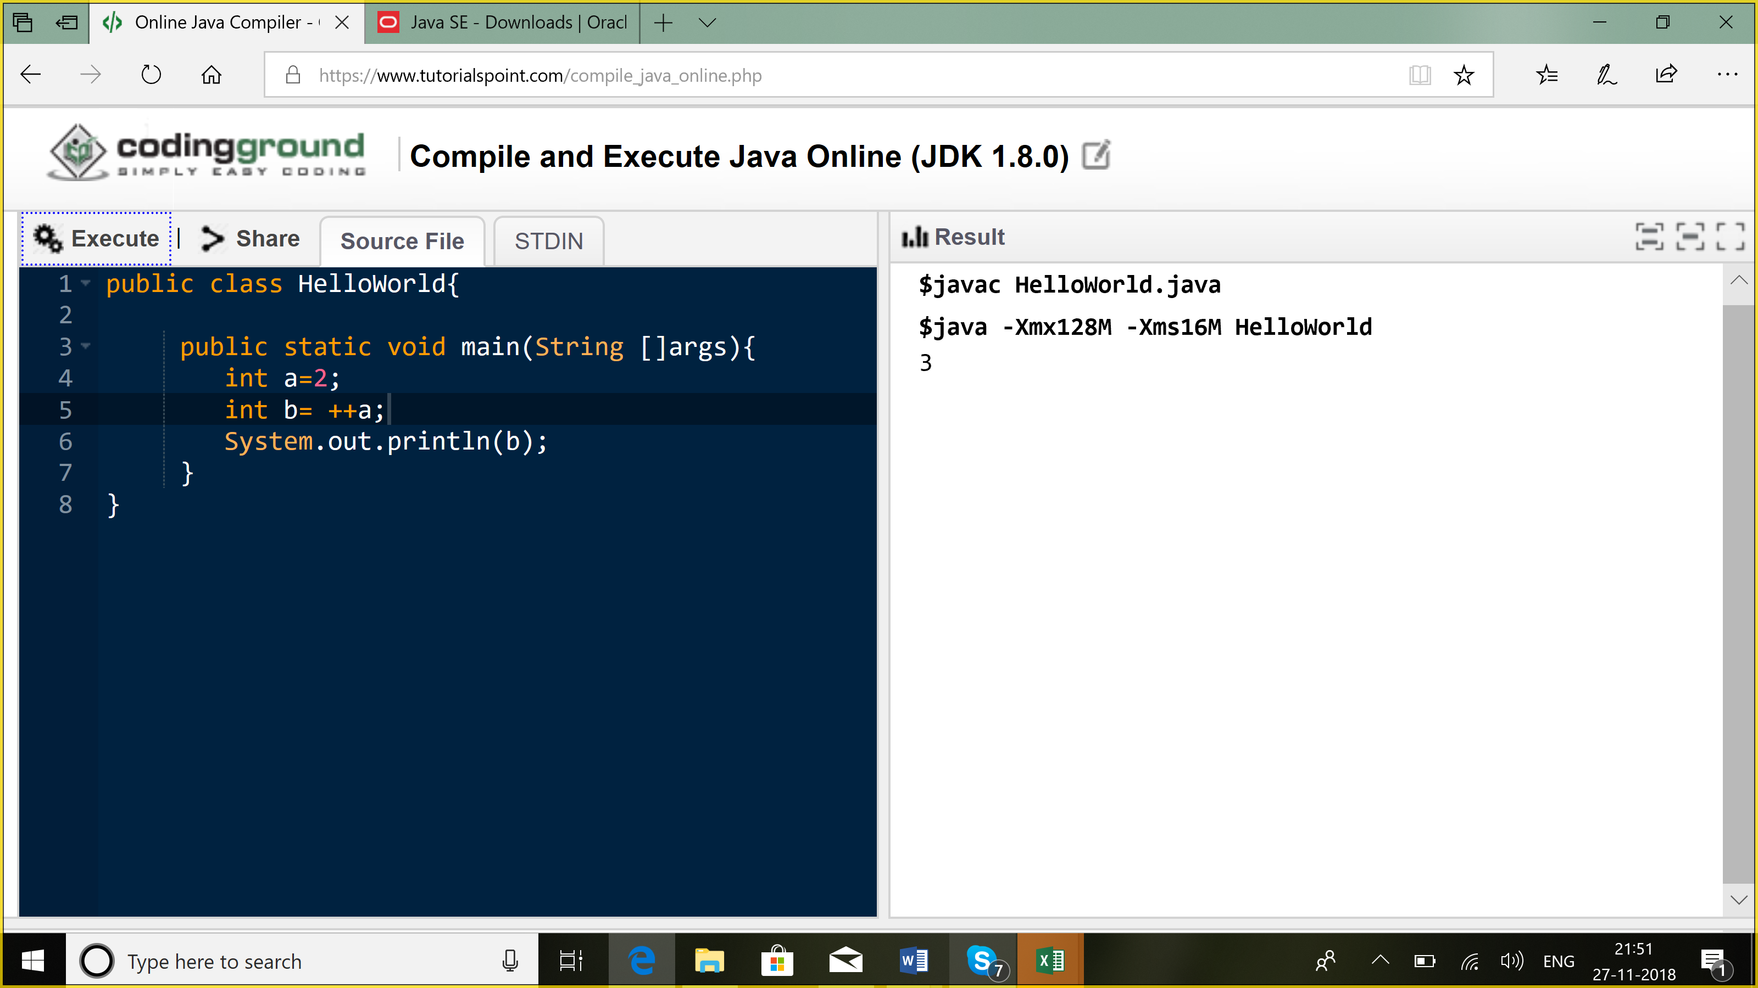

a--, --a

relational operators: <, >, <=, >=,==

==, =

Logical operators: &&, ||, &, |

Ternary operator

Int a=2;

Int b=3;

Sysout(a>b?a:b);

Implicit casting | Explicit casting?

Byte b=127; : 01111111

Short c= b; 0000000001111111

c=c+1; 00000000_10000000

Byte d= (byte)c; 10000000

Sysout(d):

Byte -> short -> int -> long(64) -> float(32) -> double

Double -> float -> long-> int -> short -> byte

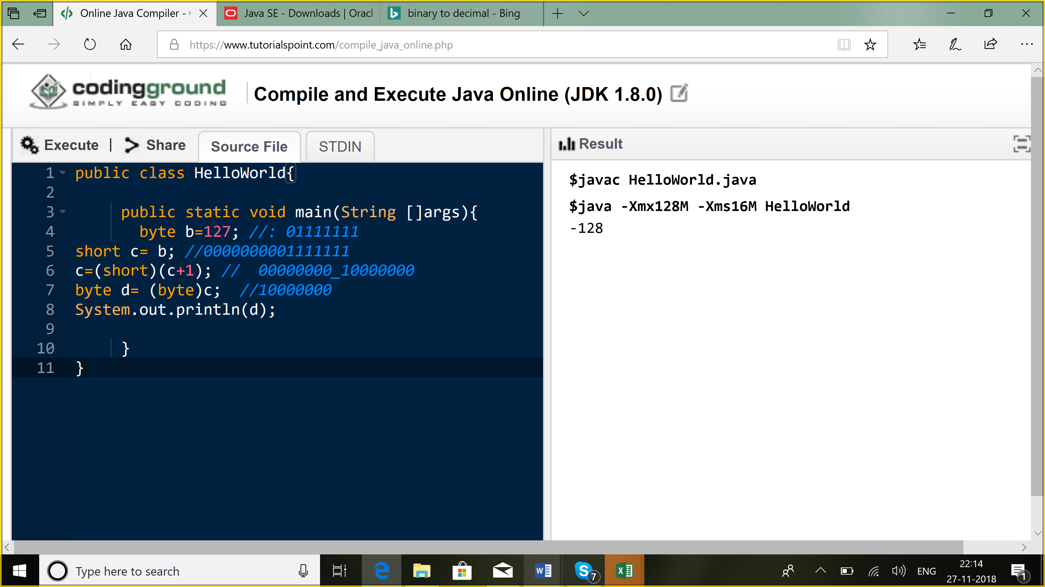

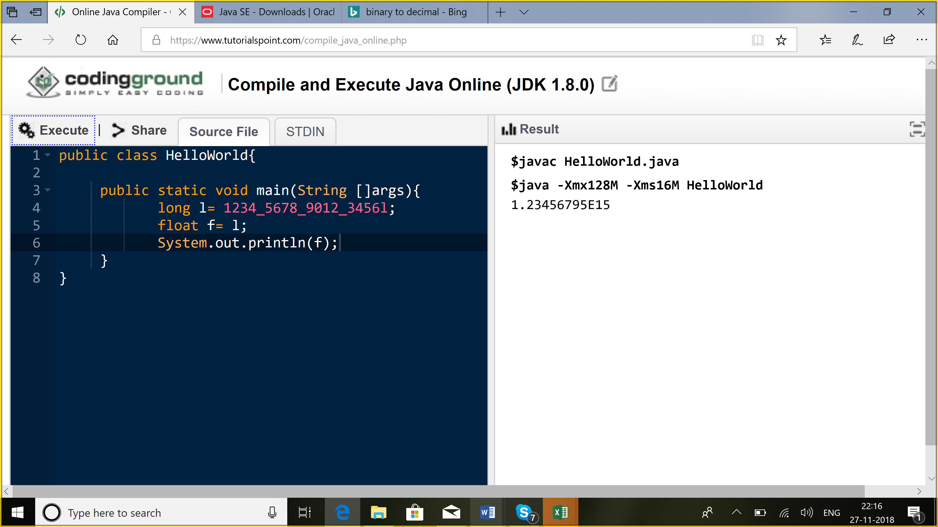

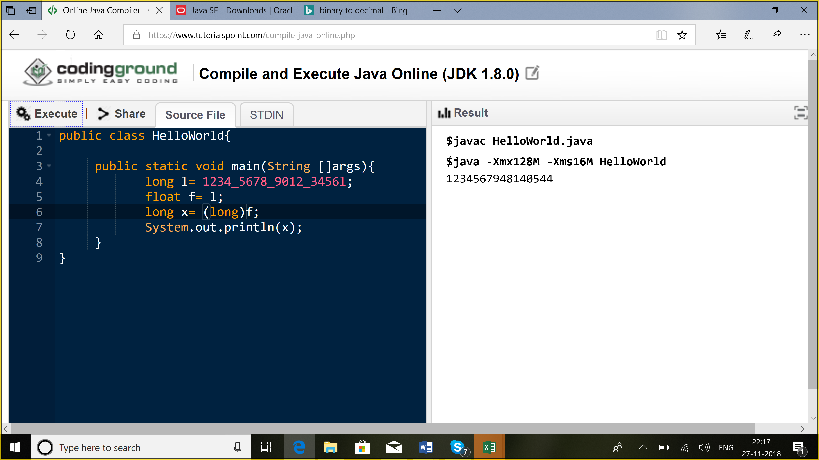

Comments

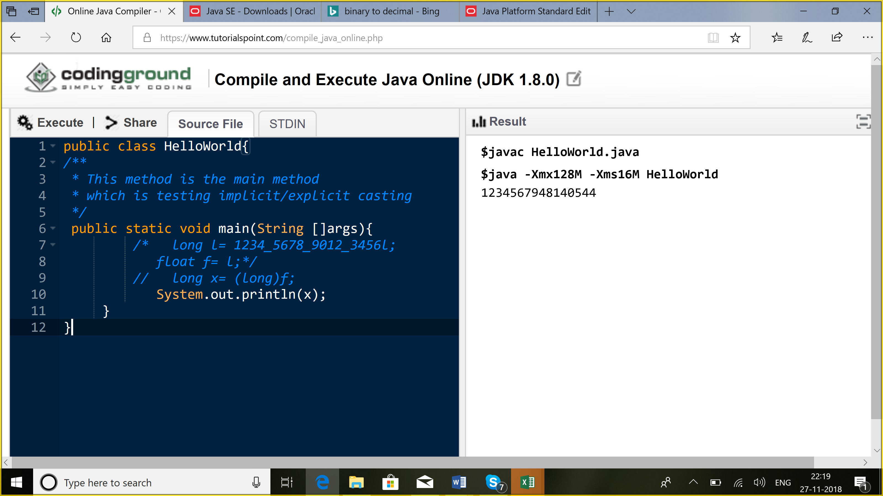

**Control statements**

1. Selection: if, if-else, switch
2. Iteration: for, while, do-while
3. Jump statements: break, continue, return

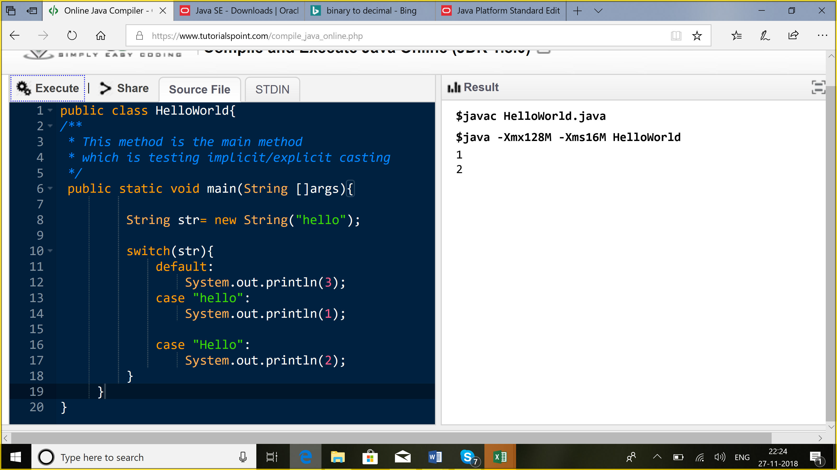

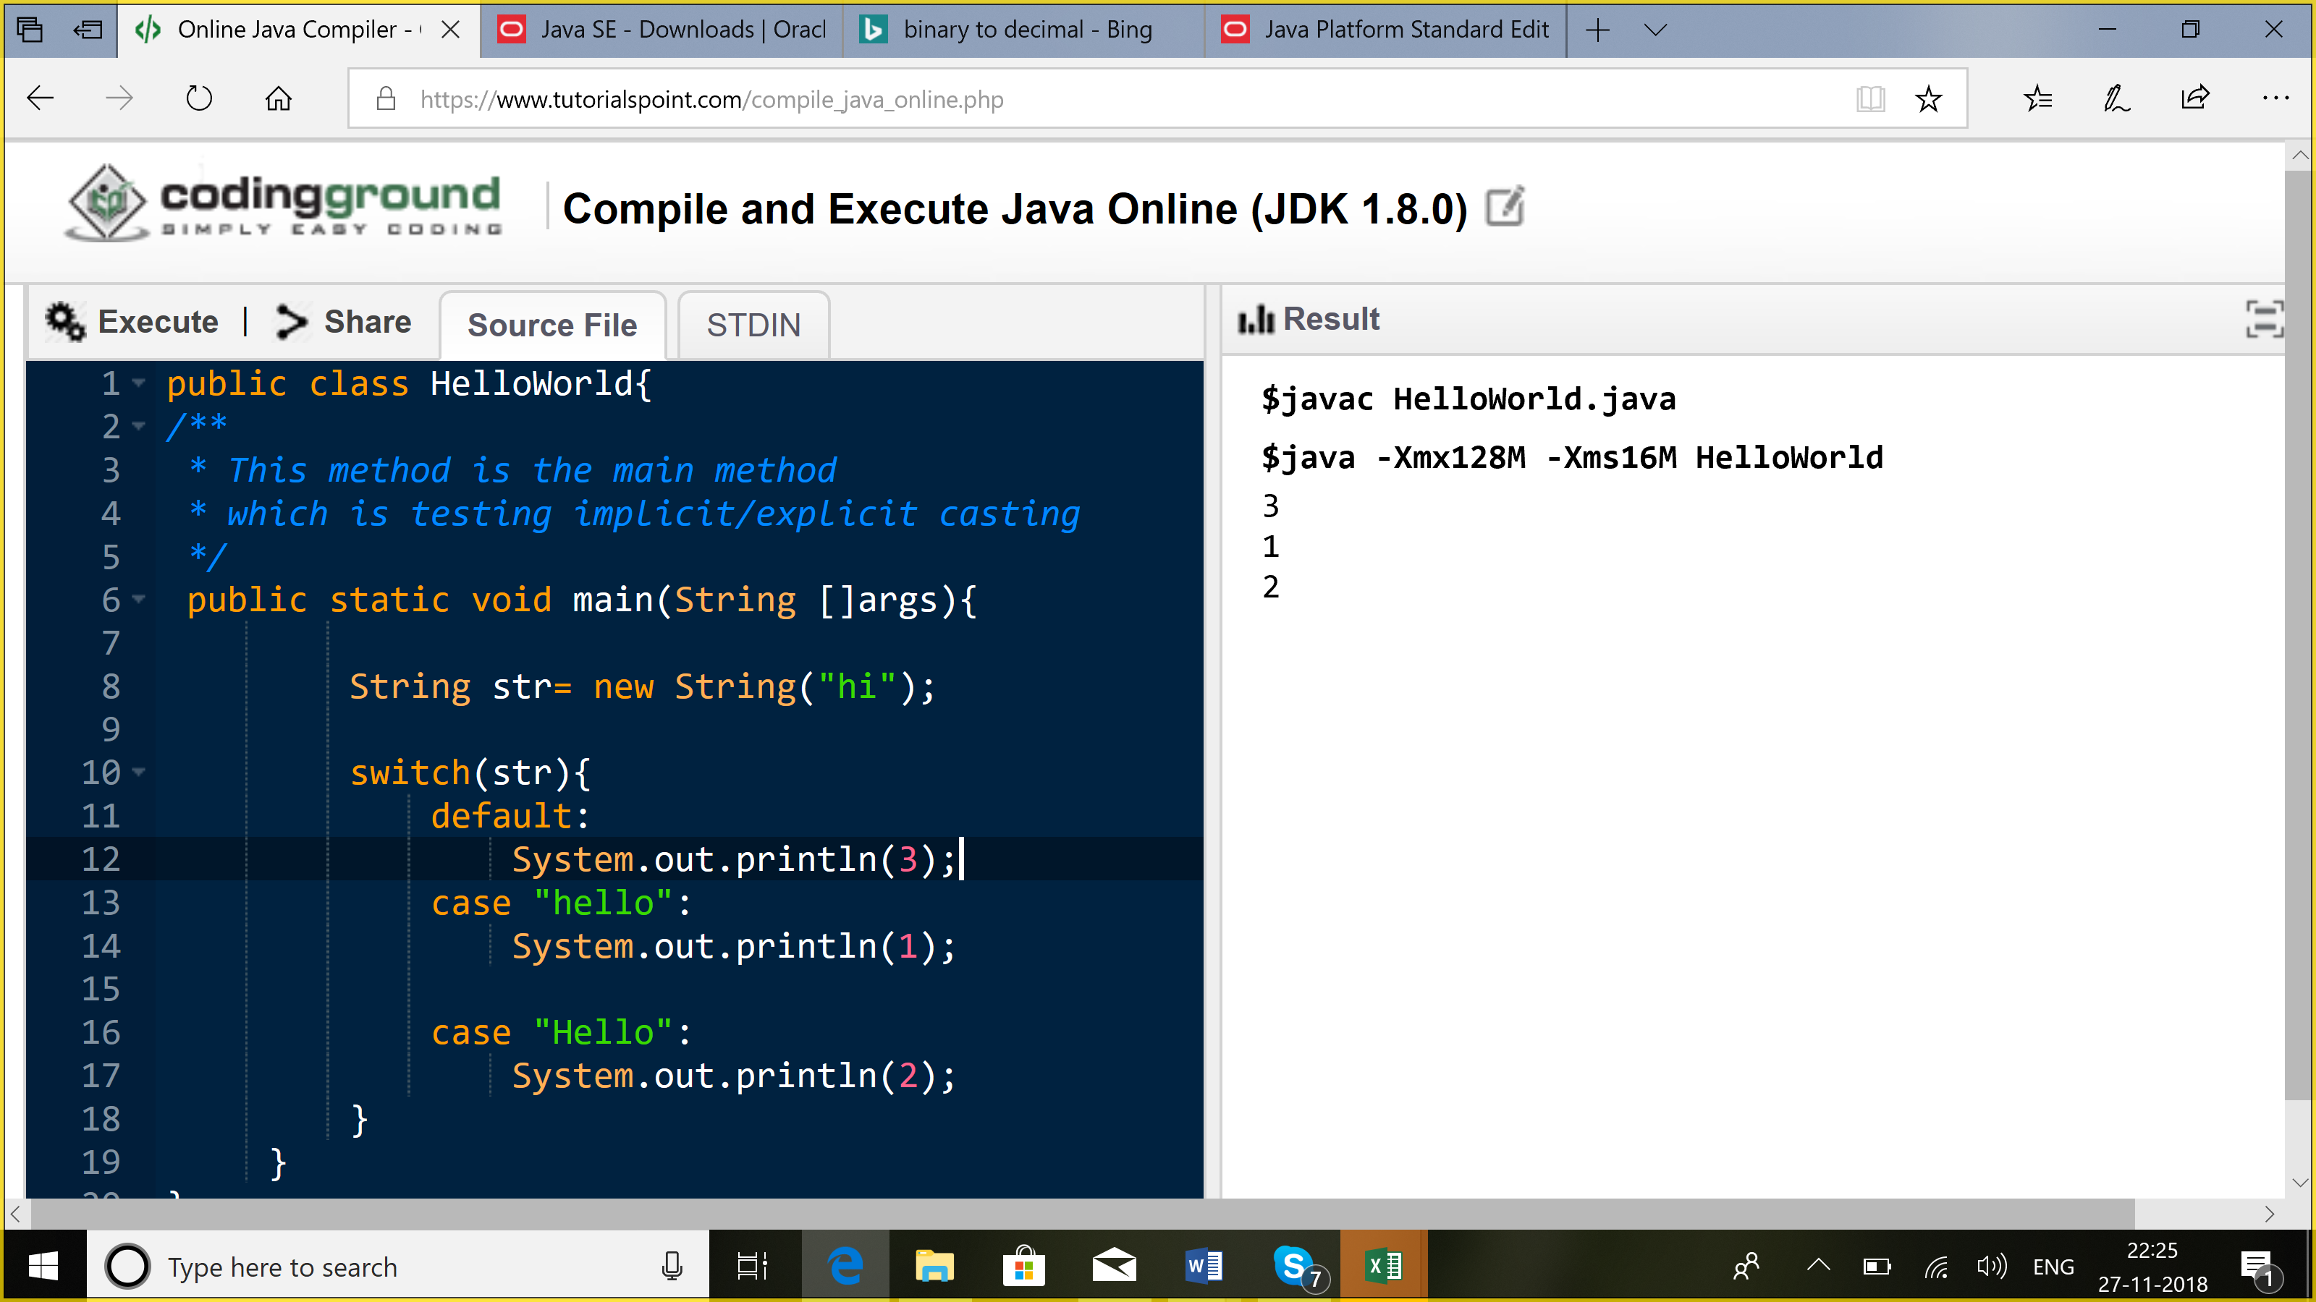

Switch: string: equals

**Equals:**

Object class: parent of all classes

Public boolean equals(Object o)

{

return this == o;

}

String, Integer, Float,….

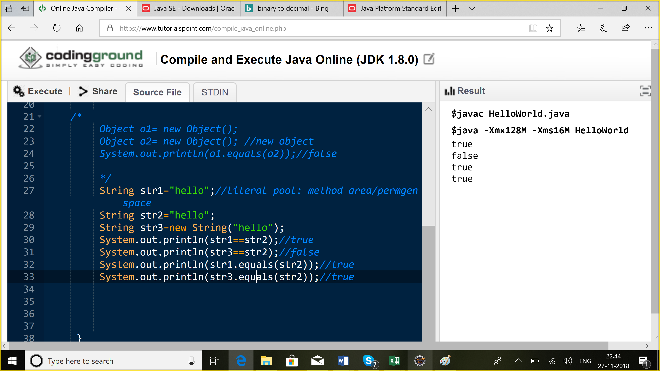

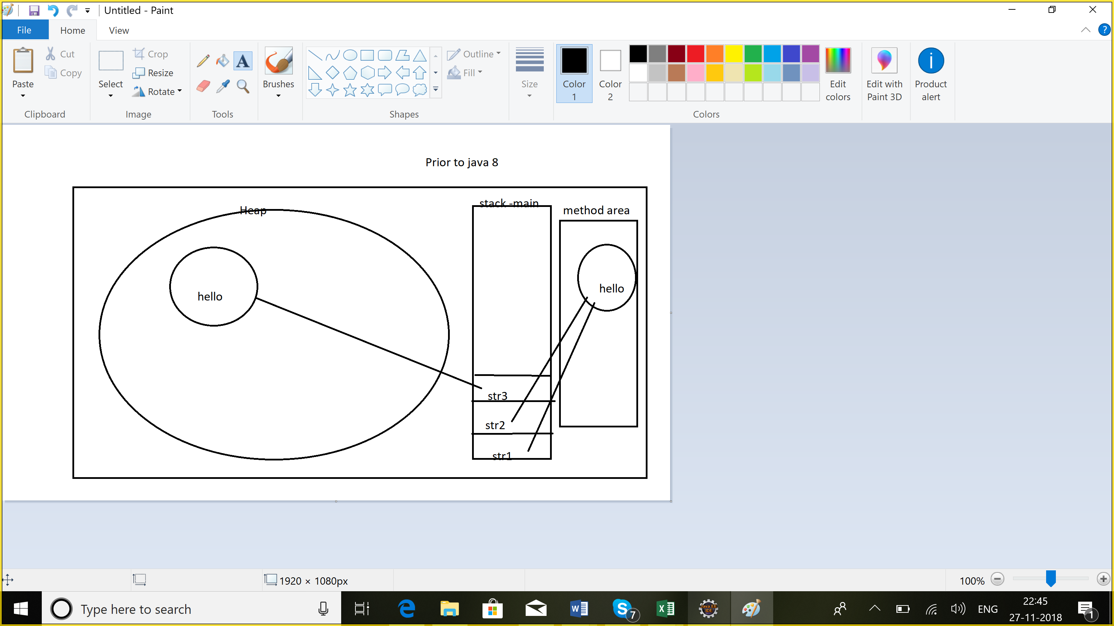

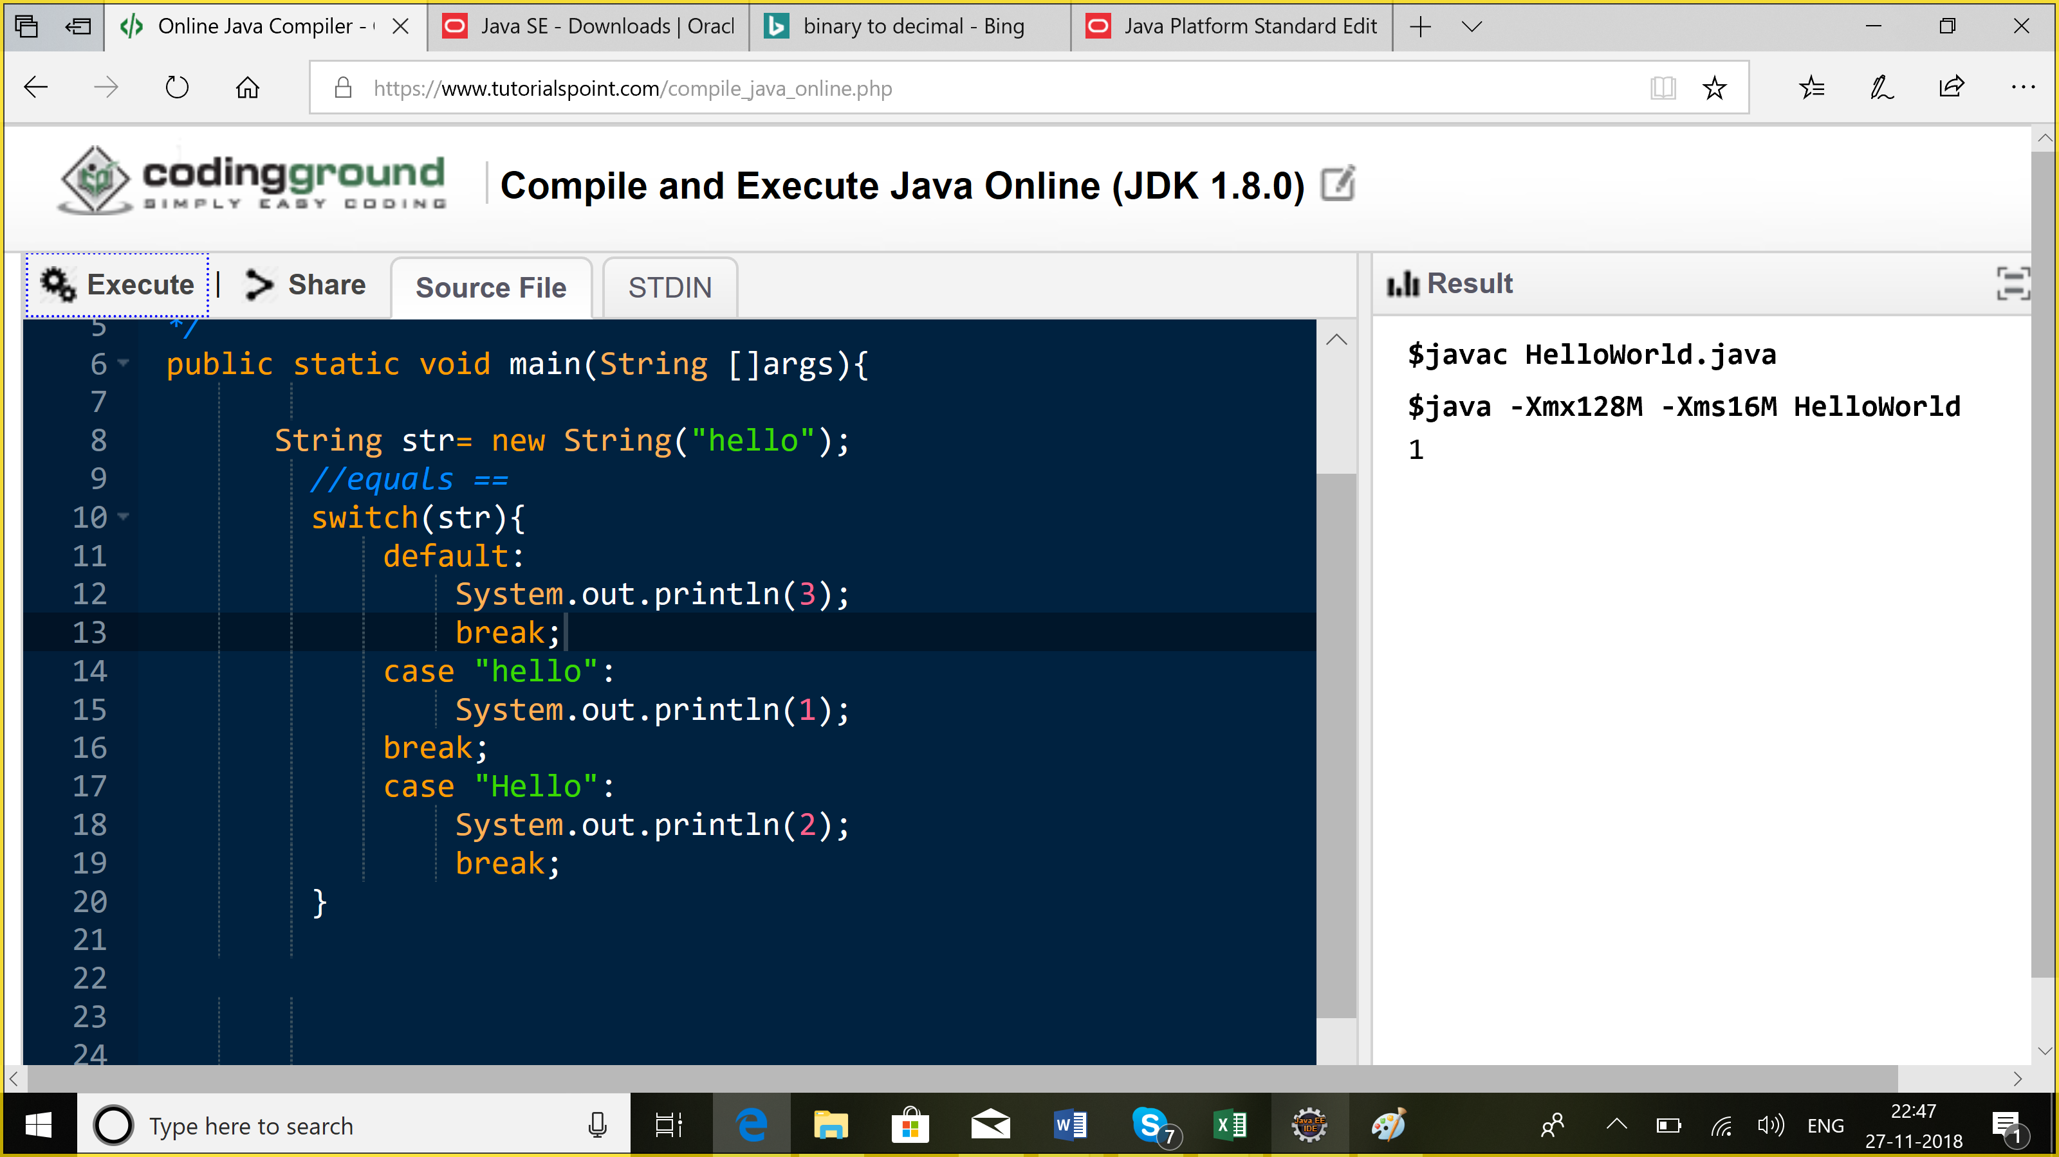

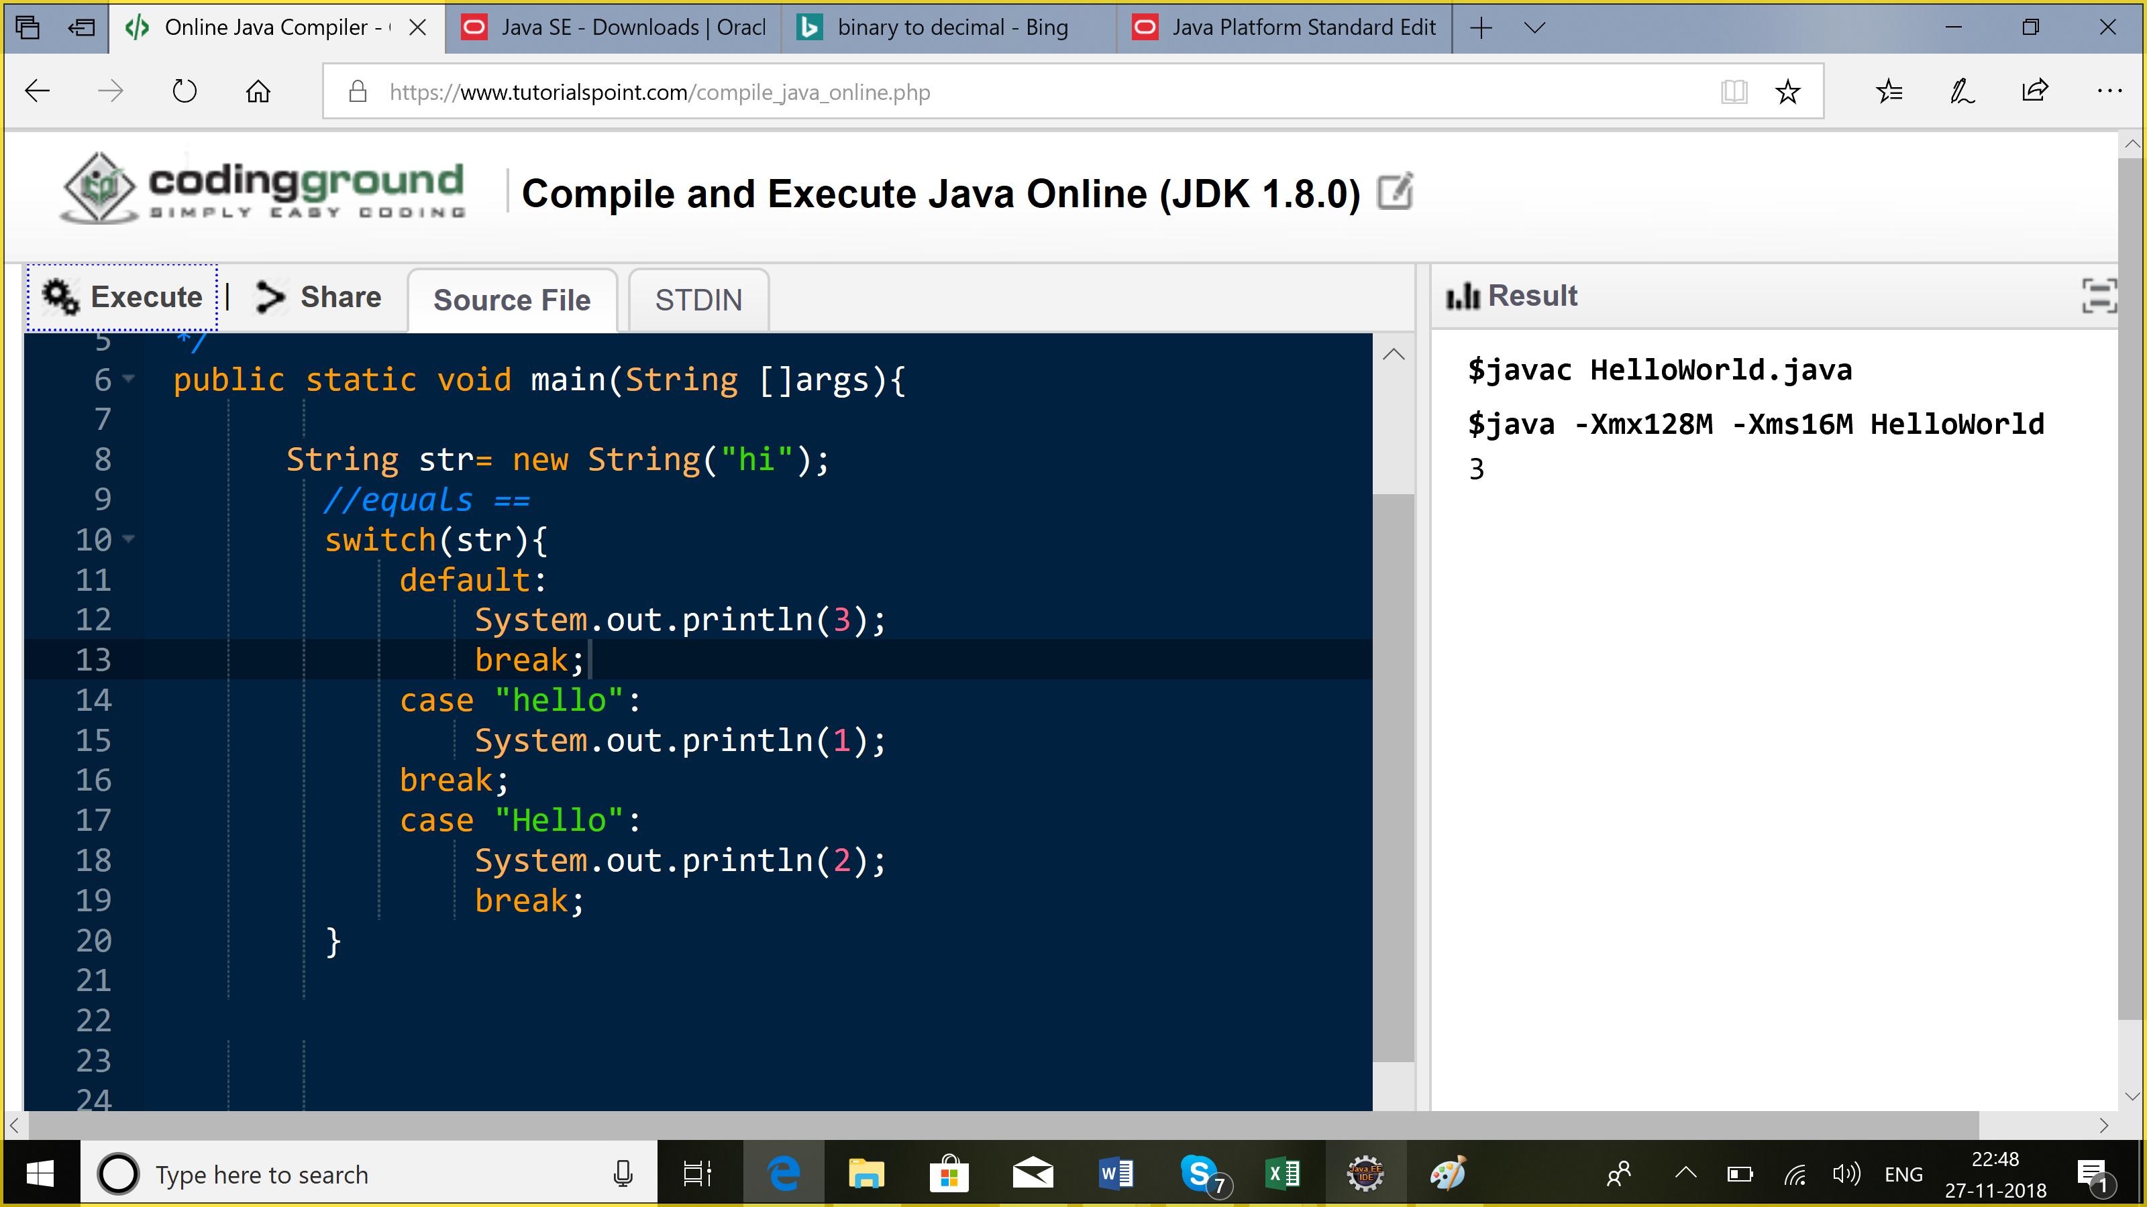

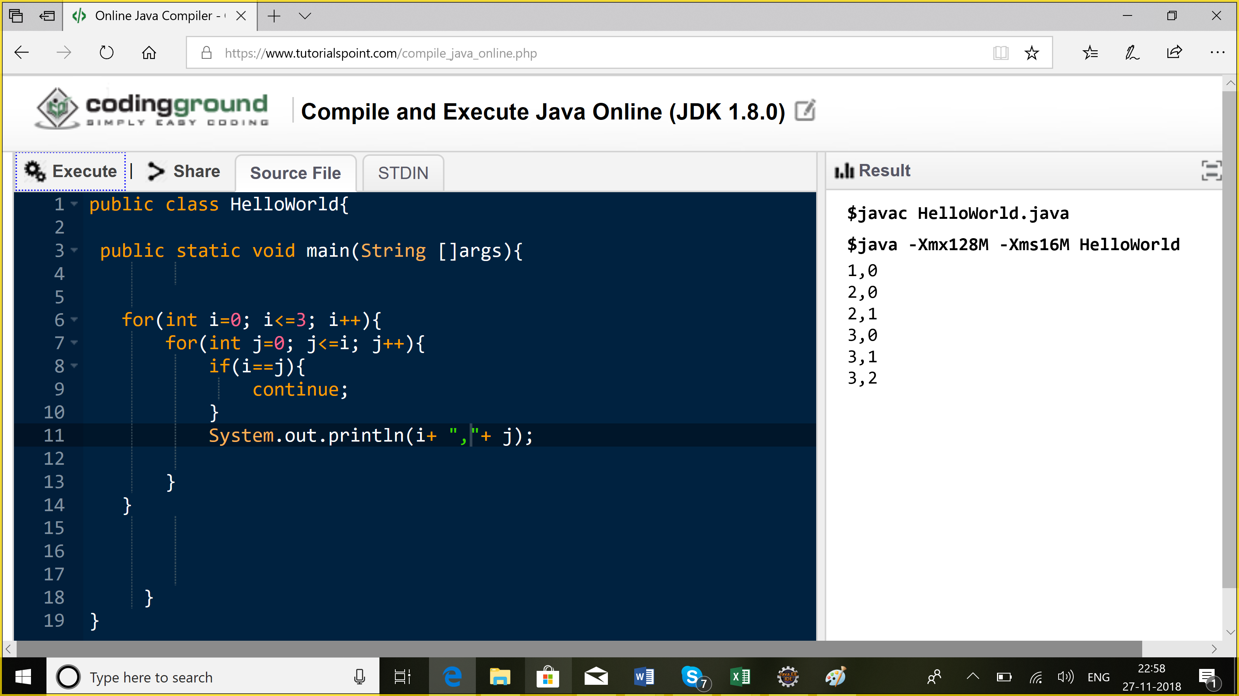

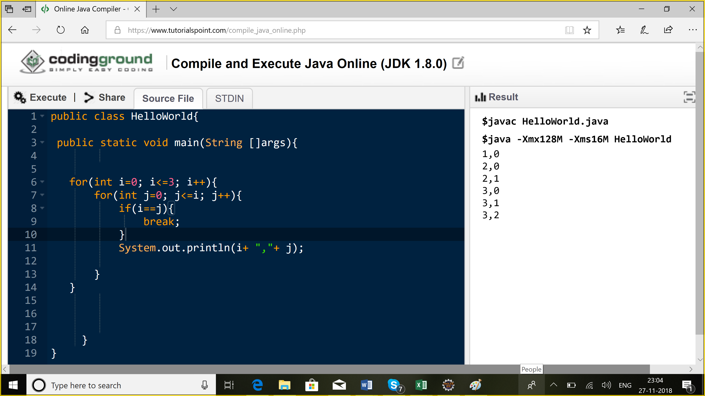

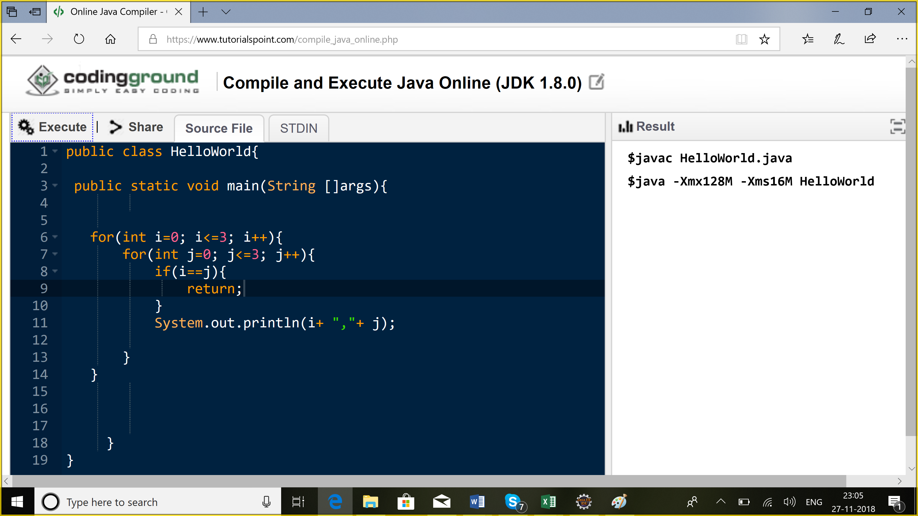

**Array:**

1. Fixed size
2. Index based
3. Elements of same datatype

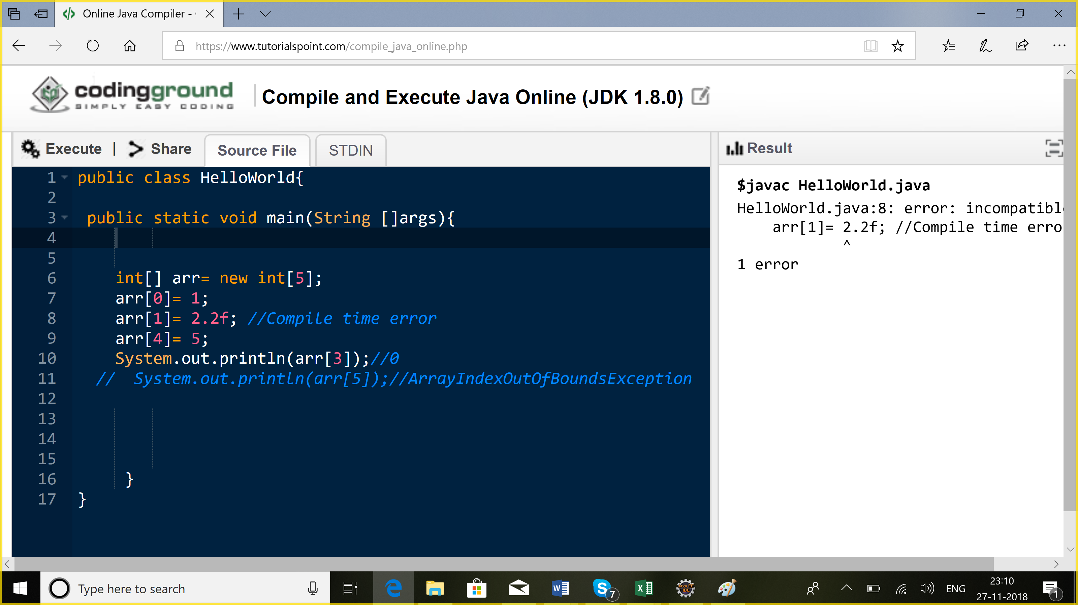

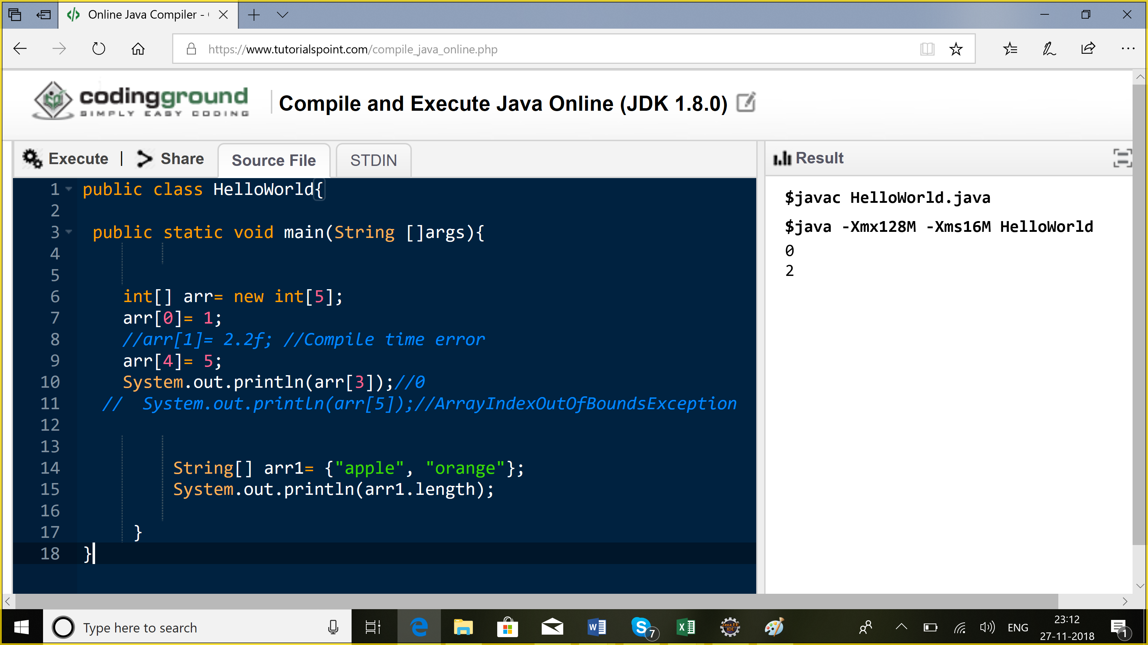

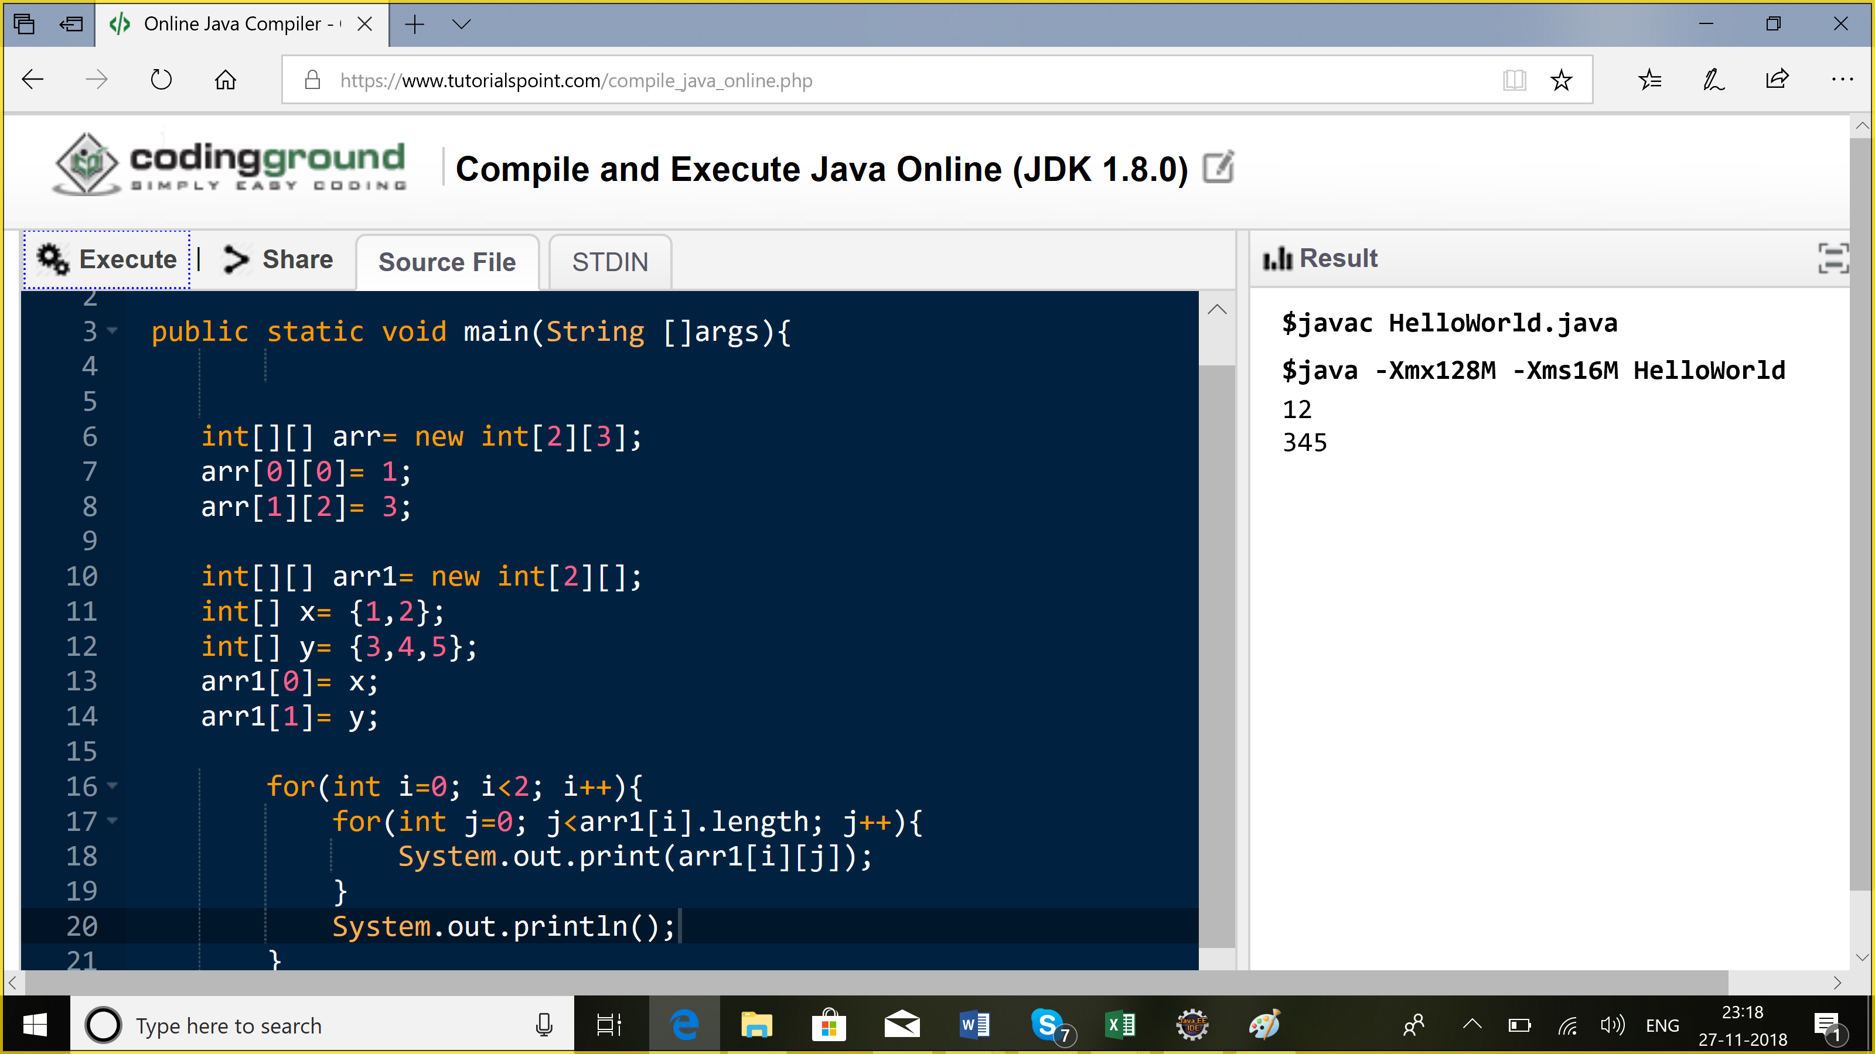

Arrays.sort(arr, Collections.reverseOrder());

**OOPS:**

1. Polymorphism: many forms
2. Add the numbers:

Int //void add2Int(int a, int b)

Float //void add2Float(float a, float b)

2

3 //void add3Int(int a int b , int c);

Public void add(int a, int b){}

Public void add(int a, int b, int c){}

Public void add(float a, float b){}

//Method overloading

//Method overriding

Class Car{

void changeGears(){

//

}

}

**Method Overriding**

1. Signature should be same
2. Return type should be same/ covariant
3. Access modifier cannot be more restrictive
4. Parent child relationship
5. Exceptions?

**Method Overloading:**

1. Arguments shud be diff. Order/number/type

Public int add(float a, int b){}

Protected void add (int b, float a){}

Add(3.4f, 2);

1. Return type: NA
2. .Access modifier: NA

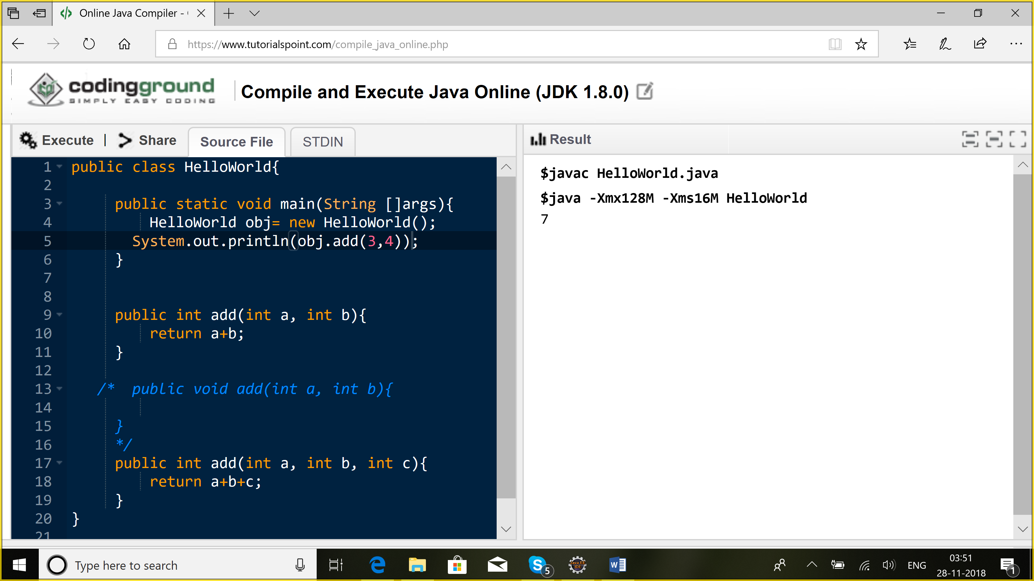

**Abstraction**

Abstract| interface

**Abstract class:**

1. You cannot create an object of this class

**Abstract method:** A method without any implementation

abstract class A{

public abstract void add(int a, int b);

}

If a class has an abstract method, then u should declare the class to be an abstract class otherwise, anyone could create an object for this class, and u call the method, then it will not know what to do.

If any class extends an abstract class having abstract method, so the extending class should provide the implementation for the abstract method or should be declared to be abstract.

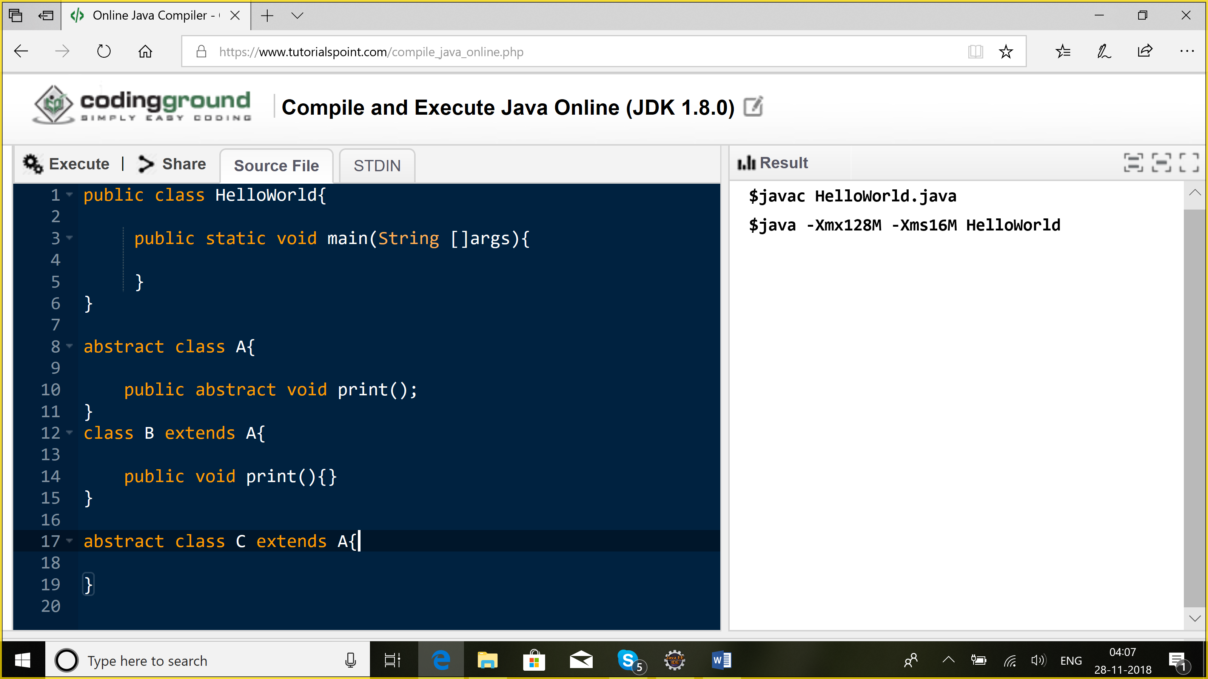

***Interfaces:***

Interface is considered to be a contract which is said to be 100% abstract class. All the methods are implicitly abstract and public.

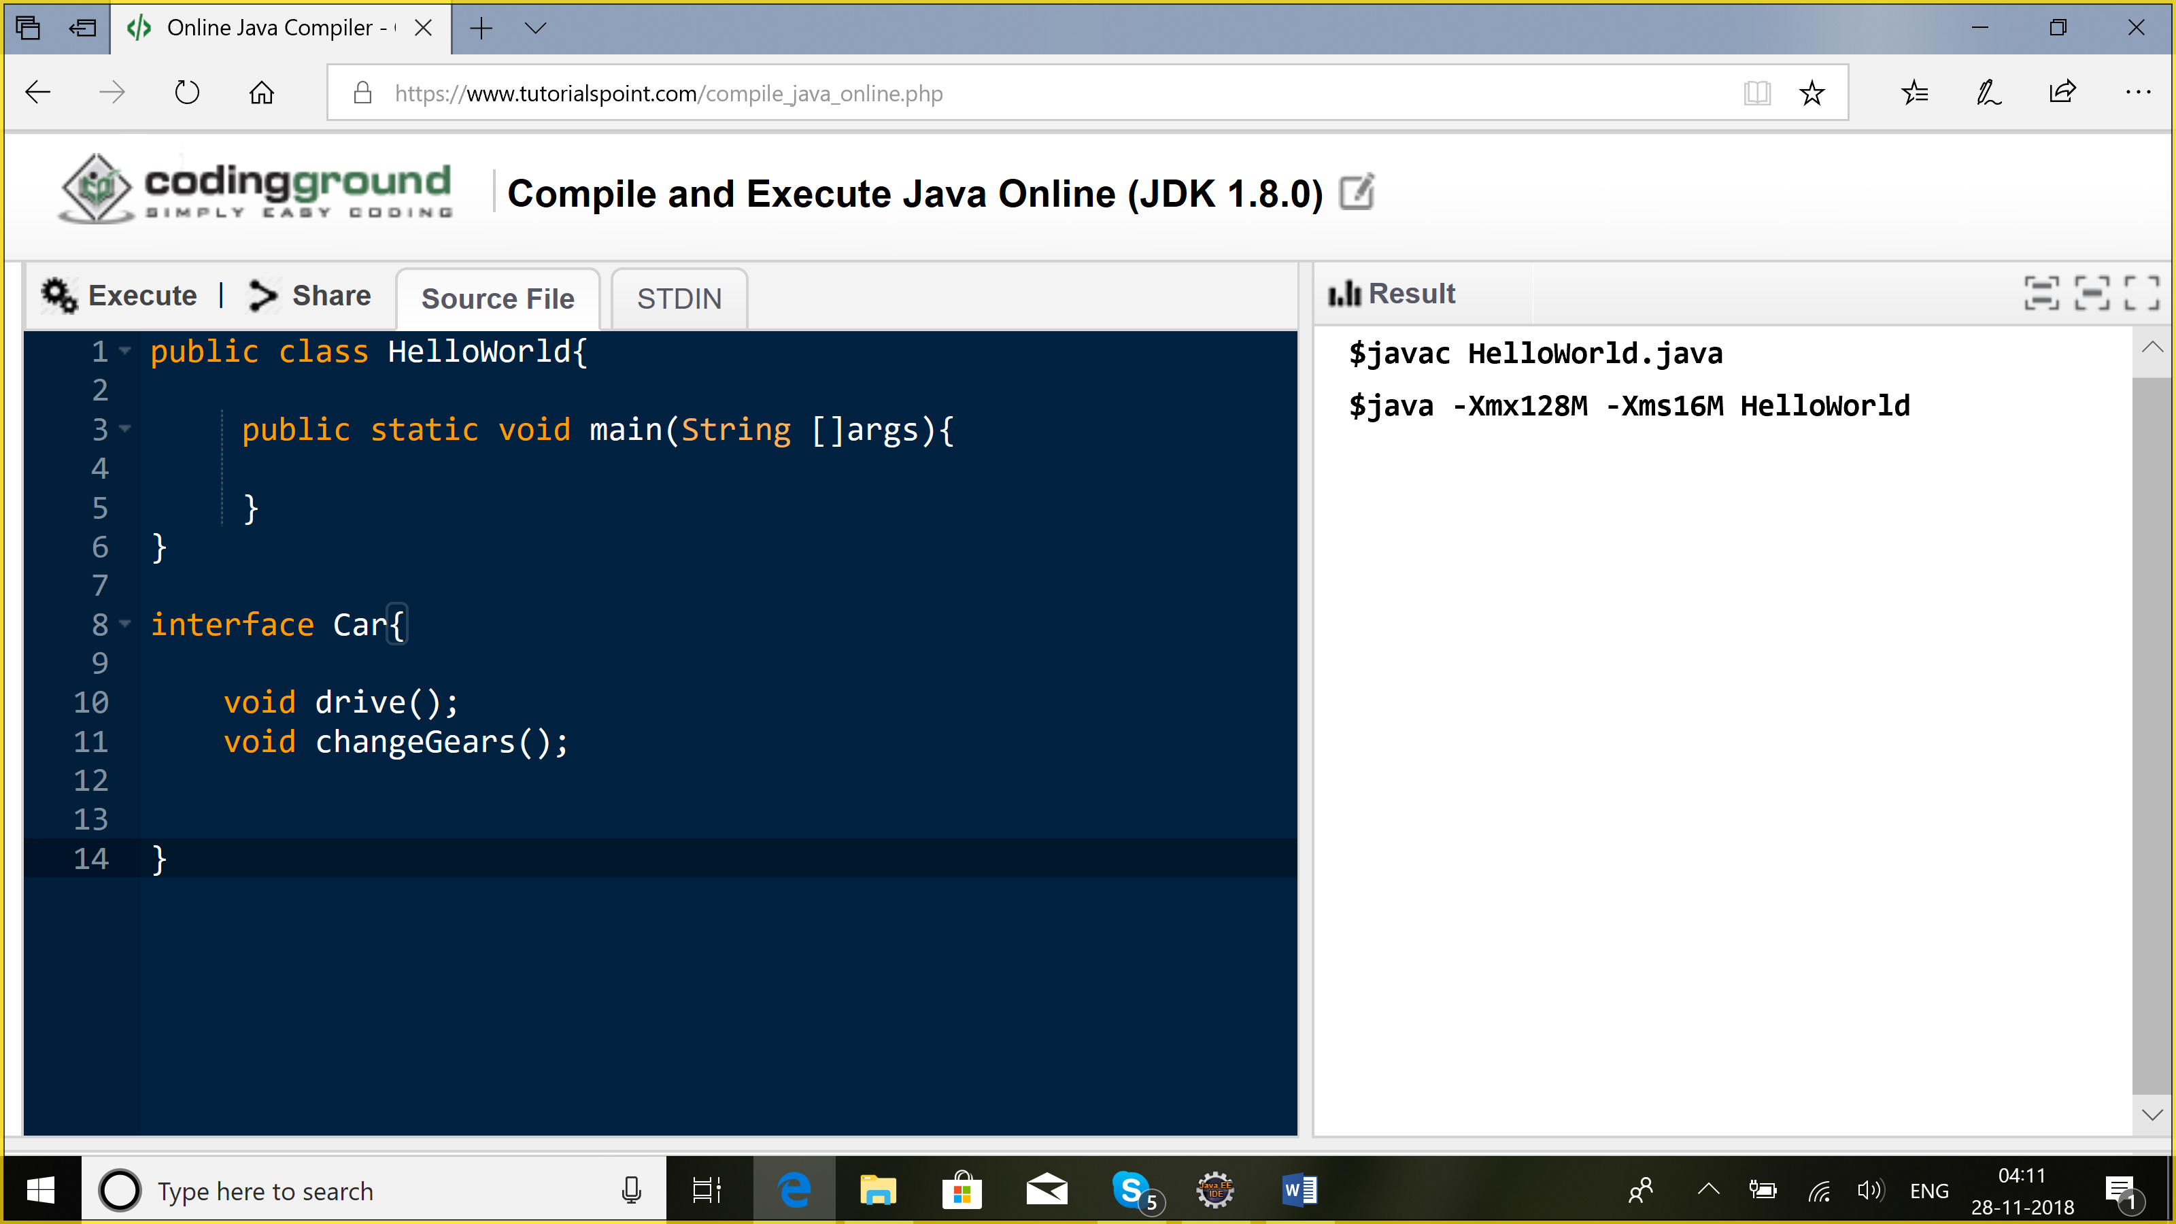

Class Car{ //abstraction//generic methods

void drive(){

Sysout(“driving”);

}

}

Class WagonR extends Car{

}

1. Inheritance
2. Encapsulation

public class HelloWorld{

public static void main(String []args){

}

}

interface Car{

float PI=3.14f;//public, static, final

void drive();//public, abstract

void changeGears();

default void listenToMusic(){

System.out.println("listening to music");

}

}

class WagonR implements Car{

public void drive(){}

public void changeGears(){}

}

class Mercedes implements Car{

public void drive(){}

public void changeGears(){}

}

A class can implement more than 1 interface but it cannot extend more than 1 class.

Multiple inheritance is not supported in java?

Multi-level inheritance

